Unit 4: Bleeding & Shock 4.1
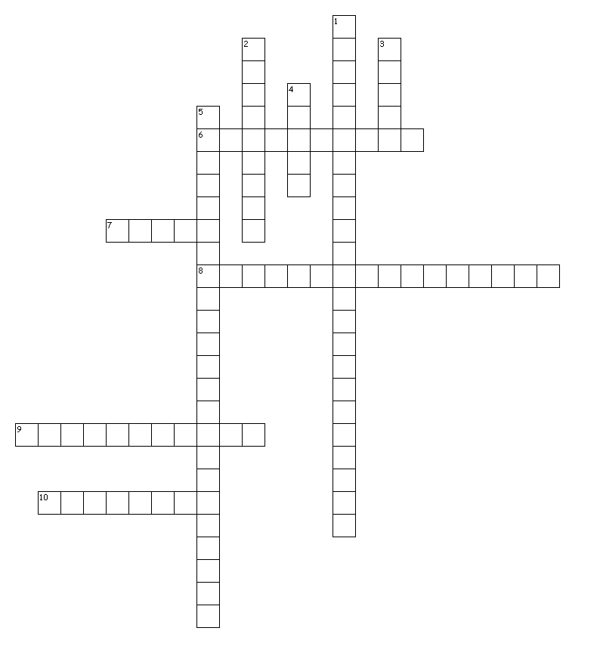
Across
6. The smallest of the arteries
7. The upper chambers of the heart
8. The heart’s own system of blood vessels
9. Tiny, microscopic blood vessels that connect arteries to veins
10. Blood vessels that carry blood from the heart to all organs and cells in the body
Down
1. The body system that includes the functions of the heart, blood vessels, circulation, and exchange of gases between the atmosphere
2. The lowest pressure in the heart
3. dressing A woven, flexible absorbent cloth applied to a wound
4. The heart’s main artery, which carries nutrient-rich blood away from the heart to the body’s cells
5. The heart’s electrical system, consisting of specialized cells within heart muscle that carry an electrical signal

Created by Puzzlemaker at DiscoveryEducation.com

