Skin Wound Classification: 3.10
Label the pictures appropriately. Describe 2-3 treatment options you would provide in each case.
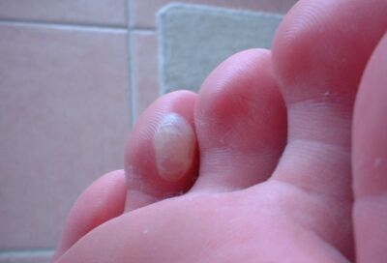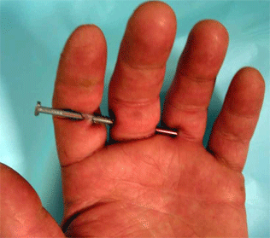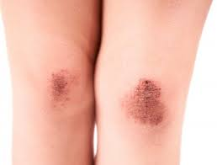
1. __________________________ 2. ____________________________ 3.____________________________
Treatment: Treatment: Treatment:

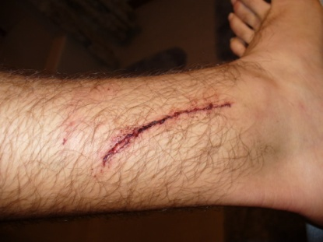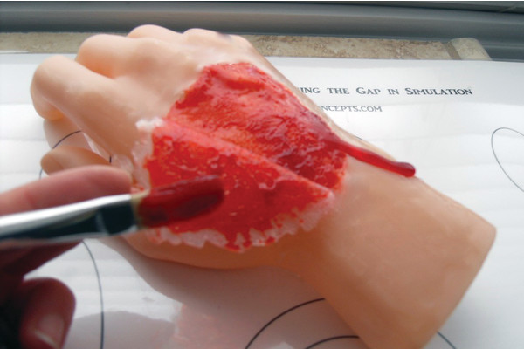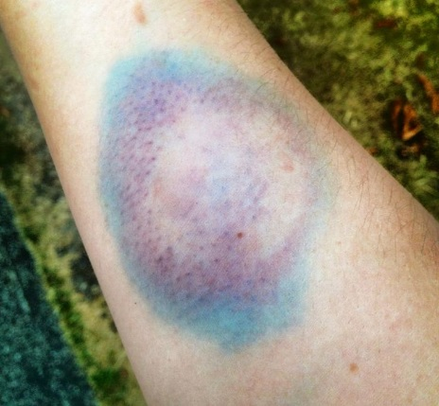
4. _______________________ 5. ____________________________ 6. _________________________
Treatment: Treatment: Treatment:

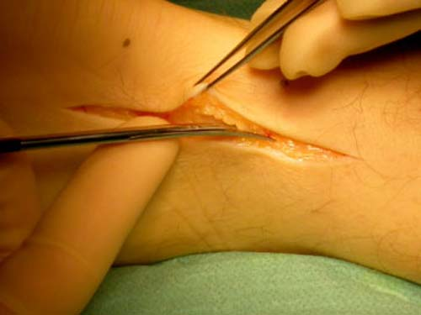
7.___________________________
Treatment:

