Use the word bank below to answer questions #1-15.
- Radius D. Carpals AC. Hamate BC. Triquetrium CD. Scaphoid
- Phalanges E. Lunate AD. Trapezoid BD. Trapezium
- Ulna AB. Pisiform AE. Metacarpals BE. Capitate

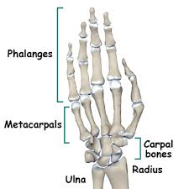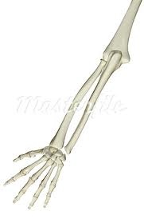
6.
1.
2.
5.
3.
4.
7.
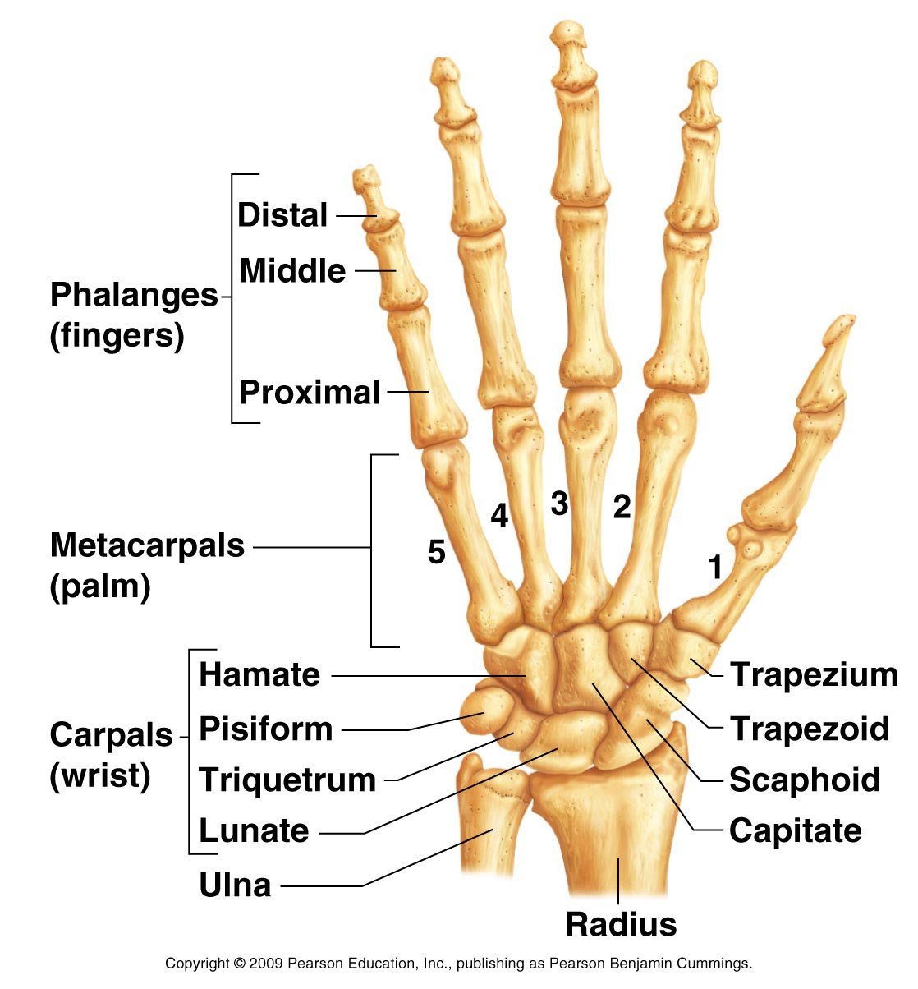

8.
9.

10.

11.
12.
13.
14.
15.

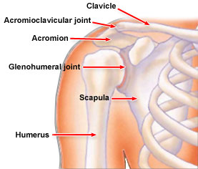
22.
16.
17.
21.
18.
19.
20.

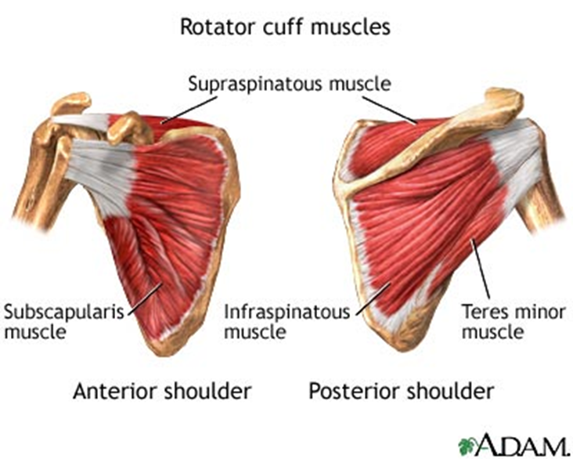

26.
25.
24.
23.

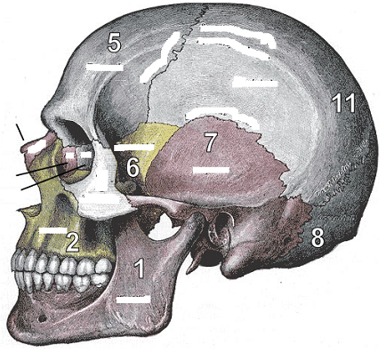
11.
10.
9.
8.
1.
7.
6.
5.
4.
3.
2.
Skull Anatomy: Match the correct number to the bones listed below.
27. _____Styloid Process
28. _____ Lacrimal Bone
29. _____ Occipital Bone
30. _____ Zygomatic Bone
31. _____ Maxilla
32. _____ Vomer Bone
33. _____ Mandible
34. _____ Parietal Bone
35. _____ Ethmoid Bone
36. _____ Frontal Bone
37. _____ Temporal Bone
38. _____ Nasal Bone
39. _____ Mastoid Process
40. _____ Occipital Protuberance
41. _____ Sphenoid Bone

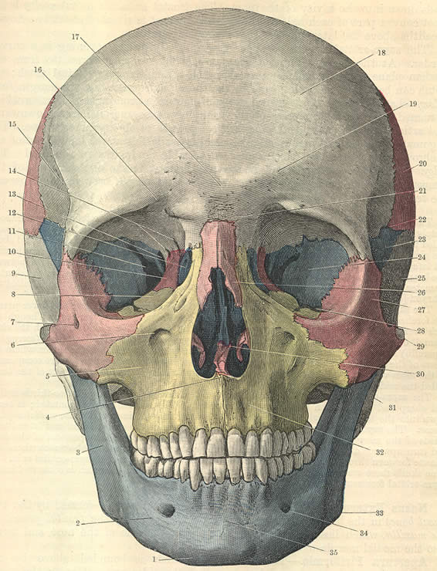

14.

15.
12.

13.

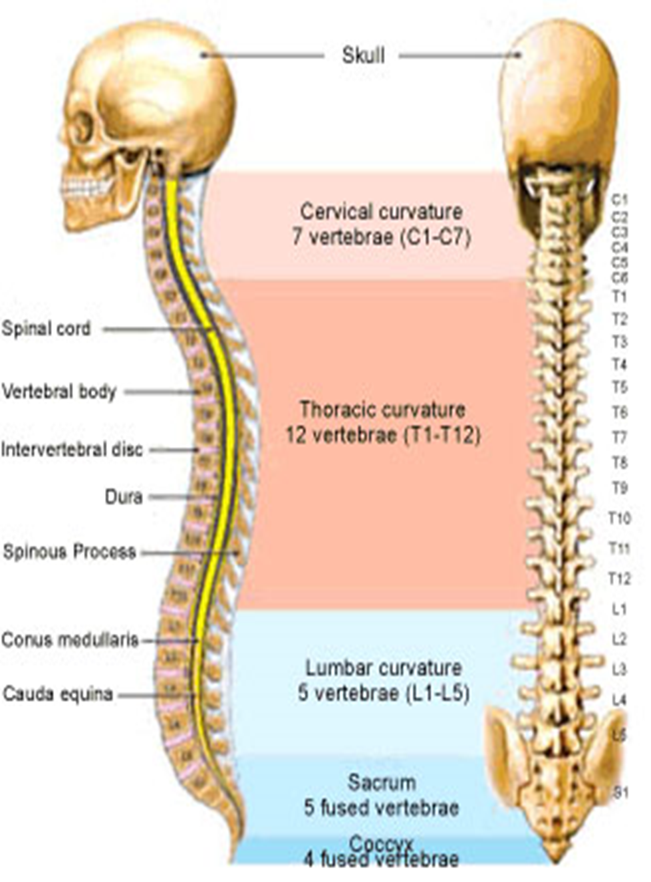
Name each set of vertebrae and list how many vertebrae are in each set.
42.
43.
44.
45.
46.
46.
45.
44.
43.
42.
51.
50.
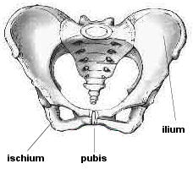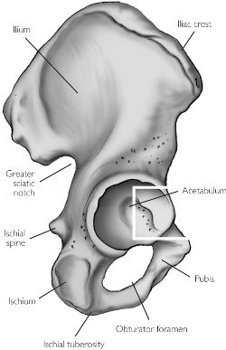
53.
52.
49.
48.
47.

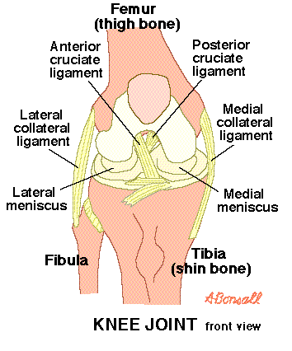
54.
55.
56.
57.
58.
59.
60.
61.
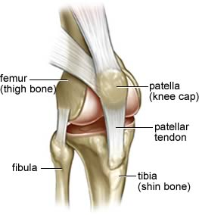
66.
65.
64.
63.
62.

Match the injury with its description.
- Bursitis C. Stress Fracture E. Hip Fracture G. Overuse Injuries
- Hamstring Strain D. IT Band Syndrome F. Groin Strain H. Quadriceps Strain

- ___Common in sports that require sideways changes in direction.
- ___Most commonly located over the outside of the hip at the trochanteric bursa.
- ___Most frequently affect the long head of the biceps femoris.
- ___Occur most often in runners and dancers.
- ___Refers to a break in the proximal portion of the femur, most common types.
- ___Involves inflammation of the IT Band.
- ___Common in sports that require jumping, kicking and repetitive sprinting.
- ___Examples: Chronic muscles strains, Stress fractures, Tendonitis, Snapping hip, Bursitis.

- injury when the space between the humeral head and acromion becomes narrowed
- Can be caused by excessive overuse or traumatic injury; pulled muscle
- Break in the bone
- These injuries involve the deepest soft tissue in the shoulder
- Inflammation of the biceps tendon
- Complete tear of the tendon; grade 3 strain
- Separation between the acromion process and the clavicle
- Results in the head of the humerus being completely out of the glenoid fossa

75. ____ Biceps tendonitis
76. ____ Impingement Syndrome
78. ____ Muscle Strain
79. ____ Rotator Cuff Tear
80. ____ Fracture
81. ____ Acromioclavicular Separation
82. ____ Glenohumeral Dislocation
83. ____ Glenoid Labrum Tear

Name the following methods that are used in Sports Psychology.
- Serves to activate or energize behavior.

- One of the most powerful techniques for human motivation.

- Helps create, modify, or strengthen neurologic pathways that are important to the coordination of muscles.

- Teaches the brain to cope with circumstances that would not be otherwise be encountered until an important competition.

Using the three categories of Sports Psychology discussed in class, classify the following psychologist:
- When a sports psychologist researches the mind and athlete’s behavior/emotions then they are considered what type of sports psychologist? (hint: they usually work at a university or lab)

- This type of sports psychologist Emphasizes working with athletes in an athletic environment.

- If the athlete wants to see this type of sports psychologist then they will have to go to the psychologist’s office.

Match the description to the injury.
- Boxer’s Fracture E. Gamekeeper’s Thumb I. Scaphoid Fracture
- Colle’s Fracture F. Ulnar Contusion J. Radial Tunnel Syndrome
- Tennis Elbow G. Carpal Tunnel Syndrome
- Golfer’s Elbow H. Cubital Tunnel Syndrome

- ___ Median nerve injury is also known as.
- ___ Lateral epicondylitis
- ___ Ulnar nerve injury is also known as.
- ___ This fracture occurs to the scaphoid bone.
- ___ An injury to the UCL ligament at the MPJ joint.
- ___ This is a fracture that occurs right above the wrist on the radius bone.
- ___ This fracture occurs to the 5th metacarpal.
- ___ Hitting your funny bone.
- ___ Medial Epicondylitis
- ___Wrist nerve impingement

Number: | Name: | Function:
I | Olfactory | 101?
102.? | Optic | 103.?
III | 104.? | Pupil Movement
IV | Trochlear | 105.?
106.? | 107.? | 108.?
VI | Abducens | Lateral Eye Movement
109.? | Facial | 110.?
VIII | Vestibulocochlear | 111?
IX | 112.? | 113?
X | 114? | Gag Reflex
115.? | 116.? | Shrug Shoulders
117.? | Hypoglossal | 118.?

A. Appendicular Skeleton B. Epiphysis C.Periosteum D.Ossification E.Osteoclast F. Remodeling
G. Diaphysis H. Axial Skeleton I.Osteocyte J. Spongy Bone K. Medullary Canal L. Osteoblast

- ____ Bone cells that build bone
- ____ The end of a long bone
- ____ Center of the shaft of a long bone
- ____ The bones of the head and trunk (skull, spine, sternum, and ribs)
- ____ The process of bone formation
- ____ Bone cells that reabsorb bone
- ____ The shaft of a long bone
- ____ Fibrous tissue that covers the bone
- ____ Bone cell
- ____ Bones of the pelvis and shoulder girdles, and limbs
- ____ Results from the breakdown of hard bone
- ____ The process of absorbing and replacing bone in the skeletal system

- Name the 3 muscles that make up the Hamstring group:

- Name the 4 muscles that make up the Quadriceps group:

- Flexor Carpi Ulnaris = Extends the 5th metacarpal
T F
134. Rectus Femoris = Extends knee, flexes hip
T F
135. Pectoralis Major = Abducts, extends, and medially rotates shoulder
T F
136. Gluteus Medius = Abducts and medially rotates thigh
T F
137. List and explain 4 injuries to the Knee.

- All PPE forms should be kept and stored for a minimum of ______ years after the athlete graduates or leaves the school due to statute of limitations.
- Main goal is to maintain the ___________________ and ___________________ of the athlete.
- Should take place at least _____ weeks before the sports season.
- What are the two parts of a sports physical?

- List and explain the three types of clearance for sports physicals.

- What connects the bones of the cranium?

- Name the 2 parts of the central nervous system.

- What part of the autonomic nervous system is responsible for the “flight or fight” response?

- Explain the following injuries and how to treat them:
- “Stinger”

- Concussion

- Second Impact Syndrome

- Cervical Neck Injuries

- Disk Herniation

- Subdural hematoma

