Ankle and Lower Leg Chapter 17
Ankle Bony Anatomy
- ________________ (link between lower leg & foot)
- Tibia
  - Medial _________________
- Fibula
  - ______________ malleolus
- Mortise
- Tibial tuberosity
- Tibial condyles
Bony Anatomy
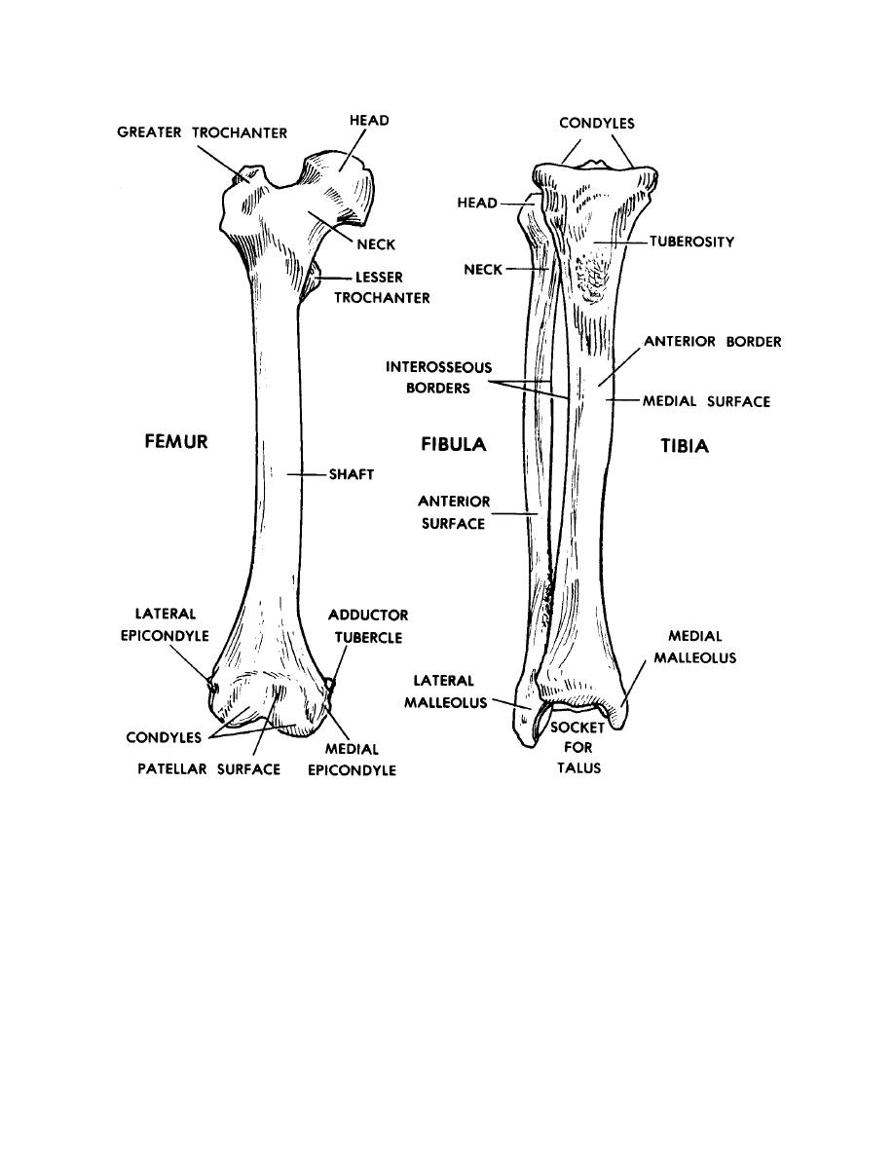
Functional Anatomy
- Ankle is a stable ________________ joint
- Medial/lateral dislocation is prevented by _________________
- Square shape of talus adds ___________________ of ankle
- Most stable during _____________________, least stable in plantar flexion
Ankle Motions
- ________________ Flexion
- Dorsiflexion
- _________________
- Eversion
- __________________
- Supination
Ankle Articulations
_______________Joint (Talocrural joint)
- Tibia & fibula with _______________
- Dome of talus articulates with __________________ formed by tibia & fibula
- Motions: ___________________ & plantar flexion
___________________ Joint
- Articulation of talus with _______________________
- Motions: ____________________ & eversion
Soft Tissue
- Gastrocnemius
- ______________________
- Tibialis posterior
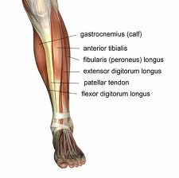
- _________________________________
- Peroneus longus
- Peroneus brevis
- _________________________
- Plantar fascia
- Anterior talofibular
- Anterior ______________________
- Calcaneofibular
- Posterior ______________________
- Deltoid ligament
  - Tibionavicular
  - ______________________
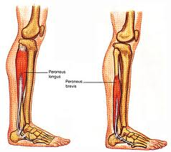
  - Anterior talotibial
  - Posterior talotibial
Muscles of the Lower Leg
- Flexor _________________ longus
- Flexor digitorum longus
- Anterior __________________
Muscles of the Lower Leg
- Peroneus tertius
- ________________________________
- Peroneus brevis
Muscles of the Lower Leg
- ______________________________
- ______________________
Compartments of the Lower Leg
- Anterior
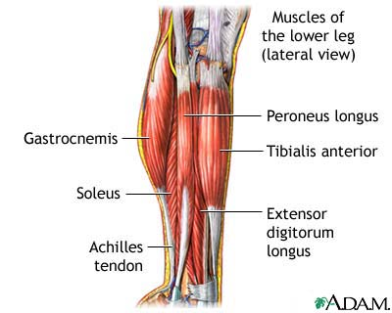
  - ____________________________
  - Extensor digitorum longus
  - __________________________________
  - Extensor ____________________ muscles
- Peroneal
  - Peroneus _____________________
  - Peroneus _____________________
- Deep Posterior
  - _____________________________
  - Flexor digitorum longus
  - Flexor hallucis longus
  - Tibialis ______________________
- Superficial Posterior
  - Gastrocnemius
  - _________________________
  - Plantaris
Ligaments
- ______________________ aspect
  - Anterior talofibular (ATF)
  - Anterior ______________________
  - Calcaneofibular (CF)
  - _____________________ talofibular
- Medial aspect
  - _________________________ Ligament
Common Injuries to the Ankle & Lower Leg
________________________
- Occur most often on tibia
- Can be painful and disabling
- Complication ____________________________________
Muscle Strains
- Most common in _____________
- Result from:
  - ___________________ contraction
  - Overstretching
  - Continued ________________________
- Usually occur in area of MTJ or insertion of Achilles tendon
- Result from:
  - __________________________ overuse
  - Single ______________________ contraction
- Acute strain to Achilles have tendency to become chronic
Cramps
- A sudden, _____________________________ contraction of a muscle
- Contributing factors include:
  - _______________________
  - Fractures
  - ____________________________
  - Lack of nutrients in diet
  - Poor _________________________
  - Improperly fitted equipment
Cramps—Treatment
- _________________ stretching
- Fluid replacement
  - ___________________
  - Sports drink
- ______________________
- __________________
- Ice
Achilles Tendonitis
- _________________________ of Achilles tendon
- Tearing of tendon tissues caused by _____________________ stress
- Occurs at point where tendon attaches to ________________
Achilles Tendonitis
- Symptoms develop __________________
- Repeated or continued overstress increases ________________________
- Pain, __________________________, redness
- Treatment
  - ________________________
  - Stretching
  - ____________________________ problems
  - Ice/Rest
  - ________________________
  - Heel lift/Achilles taping
Achilles Tendon Rupture
- Rupture occurs w/in tendon, approx 1-2” proximal to insertion
- Eccentric force applied to____________________ foot
  - Poor ______________________
  - Overexertion
- Direct_____________________
- ___________________ repaired
- ________________ = 1yr +
- Thompson test
Medial Tibial Stress Syndrome
- aka ____________________ splints
- Catchall term for pain that occurs below knee
  - _____________________ shin
  - _________________ shin
- Result of doing too much too soon
- Associated with:
  - ______________________ activity on hard surface
  - forcible excessive use of leg muscles (___________________, jumping)
  - ________________________ of gastroc and/or soleus muscles
  - improper ________________________
  - running biomechanics
MTSS Treatment
- __________________________
- Reduce activity level
- Gentle _________________________________
- _________________________________ assessment
- Orthotics
- _______________________
- Strengthening and flexibility program

Stress Fractures
- ___________________________ crack in bone
- __________________ fractures in bone that will eventually lead to full fracture if left untreated
- ______________________ stress placed on bone greater than body’s ability to heal it
Stress __________________—S/Sxs
• “___________________” of sharp, intense pain upon palpation
- Shin-splint
Stress Fx
- Pain worse in ______

- Pain more generalized
- Pain worse in ________
Compartment Syndrome
- _____________ within one or more of the compartments of the lower leg
- Caused by:
  - ___________
  - Fracture
  - Crush injury
  - Localized infection
  - Excessive ________________
  - Overstretching
Ankle Sprains
- MOI: combo of excessive ____________________ and PF
  - aka lateral ankle sprain
- Anterior Talofibular Ligament (ATF)
  - Calcaneofibular (CF)
  - Posterior talofibular (PTF)
- Eversion (____________) ankle sprain less common
  - ________________ ligament
Ankle Sprains
- Injury to ligamentous and capsular tissue
- Traumatic joint twist that results in stretching of total tearing of the stabilizing connective tissue
- One of most common & disabling sports injuries
- General Symptoms:
  - Point tenderness
  - Skin discoloration
  - Joint swelling
  - Local temperature increase
  - Pain
Ankle Sprains
- _________________
  - Anterior Talofibular
  - Calcaneofibular
  - Posterior Talofibular
- __________________
  - Deltoid Ligament
- __________________
  - High ankle sprain

Ankle Sprain—S/SXS
- Grade 1
  - Some pain
  - Minimum LOF
  - Mild point tenderness
  - Little or no swelling
  - No ______________ ________________
- Grade 2
  - Pain
  - Moderate LOF
  - Swelling
  - Slight to __________ _________________
- Grade 3
  - Severe sprain
  - Extremely painful initially
  - LOF ___________________
  - _____________ _________________
  - Tenderness
  - Swelling
        - May represent subluxation that reduced spontaneously
Ankle Sprain—Treatment
- Splint, tape, brace
- Compressive wrap
- Horseshoe

- ____________
- Crutches
- ____________
Special Tests & Rehabilitation
Anterior Drawer
- Tests integrity of ______________ _______________ ligament
Talar Tilt
- Tests integrity of ____________________ ligament
Squeeze Test
- Squeezing the tibia and fibula together
- Can indicate ______________ or high ankle _____________
Bump Test/Tap Test
- Bump calcaneus
  - Indicate ______________ to tibia/fibula
  - Indicate high ankle ___________
- Tap mallelous
  - Indicate ______________ of particular bone
Ankle Rehab
- 4-way ___________________
- Heel walks/Toe walks
- 3-way ____________ ________________
- Unilateral Balance
- 3-way Tramp throw

